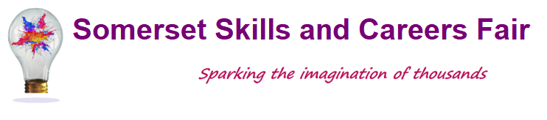
Exhibitor Booking Form
Wednesday, 2nd October 2024 - Westlands Leisure Complex, Yeovil

The Somerset Skills and Careers Fair opens up a whole world of new opportunities for young people, introducing them to new vocational skills and giving them the chance to explore future career opportunities.

Organisation Details
Company Name:
Address:

Contact Name: | Tel: | Email:
Please provide a few words about your organisation for us to use in the Exhibitor Directory
(Include web address, Twitter handle and Facebook page if available)

Invoice Details
Invoice address
(If different from above)

Purchase order No. (if required)
Finance Contact: | Tel: | Email:

Exhibition Space
Each exhibition space costs £250 and includes:
- 1 x standard trestle table, 2 x chairs
- Tea/coffee throughout the event for a max of 2 people

Early Bird discount £230 applies if booked before the end of March 2024

Power can be supplied for a small charge and additional refreshment packages can be purchased as required
Space is available in multiples or bespoke upon request – please contact us to discuss your requirements.
Lunch can be purchased on site during the day.

I would like to book exhibition space for Wednesday, 2nd October 2024
No of stands required | Cost (@ £250 per stand)  * Early bird booking - £230) | Power (@ £10 per stand)  If required | Cost
 |  |  | £
* Early Bird booking only applies if booked before the end of March 2024
If you require additional space, please call to discuss
Sub Total |  |  | £
Additional Information
 |  |  |  | Cost
Number of people on your stand |  | Qty:
Additional refreshment package @ £5 per person |  | Qty: |  | £
 |  | Sub Total |  | £

Invoice Total | £

Please let us know if you have any additional or unusual requirements and we will do our best to accommodate you.

Terms and Conditions
By signing this booking form you are agreeing to:
- Ensure your stand is staffed at all times for the duration of the event
- Comply with the Health & Safety at Work Act 1974 and any regulations made there under
- Pay the exhibition stand cost as detailed above, this will be invoiced to you once your booking has been confirmed
Cancellations
- Should be made in writing
- Cancellations made within two weeks of the event will incur the full cost of the original booking
- Cancellations made within a month of the event will incur a £100 admin fee

Signed in agreement:
Print Name:
Position:
Date:

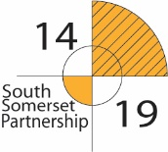
Please send the completed form to Sarah Johnson: admin@somersetcareersfair.co.uk
Once your booking has been received confirmation will be sent to you via email.
For further information please contact: Sarah Johnson on 07714 396346

